Computer Organization & Architecture
Program 3- B17 Simulator

By Zachary Owen
With ‘Special’ thanks to Elliott Rarden, Allison Bodvig, and Anthony Morast

Introduction
The B17 Simulator is a 24-bit word-addressable accumulator architecture. It supports up to 64 instructions, up to four addressing modes, and 2¹² (4096) words of memory.Main memory consists of 4,096 words, each of which is 24 bits wide. Addresses are 12 bits wide, and range from 000 through FFF. Within theword, bits are numbered from right to left, with bit 0 the least significant bit and bit 23 the most significant bit. The memory interface transfers one word of data at a time. Communication with memory is via two registers, MAR and MDR.
The input file consists of three separate objects -memory address, number of instructions and instructions. The first vale read from a input file is the memory address followed by the number of instructions.Once both these values are read in ,the firstinstruction is read in the given memory address and and the next subsequent instructions are saved in the subsequent memory addresses until we are done with all the given nmber of instructions.
For every instruction read in, a trace line is printed out on the console window. The trace line contains the following information-the address of the instruction(three hex digits), the instruction itself(six hex digits),the instruction mnemonic(four characters), the EA being used by this instruction if it uses a memory address(three hex digits) or “IMM” if it specifies an immediate operand, or three spaces and lastly the contents of AC(accumulator) and four index registers(X0,X1,X2,X3) after the instruction has been executed.The program only stops running when a HALT instruction is executed,an undefined OPCODE is encountered, an unimplemented OPCODE is encountered, an invalid or illegal addressing mode is specified for execution or an unimplemented addressing mode is encountered.

Registers and Busses:
Figure 1.1: Registers
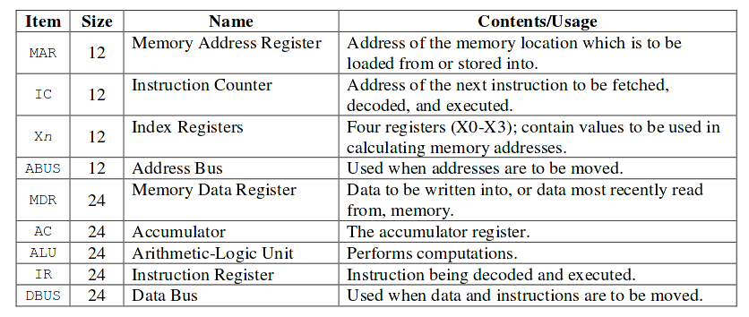
The Registers and Busses are implimented as global externs defined in “globals.cpp” and initialized in “b17.cpp”. In general the communication is only allowed between a bus and a registers, or a register and a bus. The only exception is that the Index Registers are alowed to communicate directly with the Accumulator. There is also a Hidden register called ‘EA’ which is used to hold the calculated Effective address calculated each cycle, and is helpful in printing the Trace information each cycle.

Addressing Modes:
The B17 Simulaton is allowed to access memory for operands in 5 legal ways. These way’s are; Direct, Immediate, Indexed, Indirect, and Indirect Indexed. The accessing is handled by the getVal() and getEA() functions (found in operators.cpp). Operands use the addressing modes in different ways but in general most simple use getVal() inorder to get the information sored at that place in memory. OpST(), the store instruction uses getEA() so that it can know where it will eventually store its data.
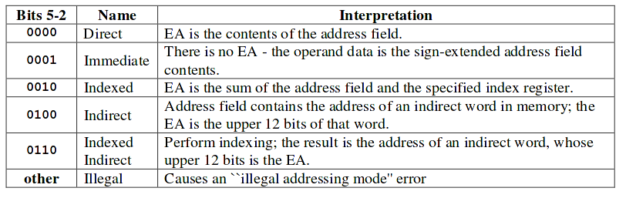
Figure 1.2: Addressing Modes

The following table gives you a look about each instruction and the legal addresing modes for it.
All –The following instructions can work along with any of the addressing modes.These instructions are : LD, ADD, SUB, AND, OR and XOR.
Direct –The following instructions can work along with only direct addressing mode. These instructions are : STX and EMX.
Immediate,Direct -The following instructions can work along with only direct addressing mode
and immediate addressing mode. These instructions are : LDX, ADDX and SUBX.
All except Immediate –The following instructions can work along with any of the addressing modes but the immediate addressing mode.These instructions are : ST, EM, J, JZ, JN and JP.
Ignored –The following instruction don’t takethe addressing mode into account while execting.These instructions are : HALT, NOP, CLR, COM and CLRX

Opcodes:
Figure 1.3 Opcode Diagram
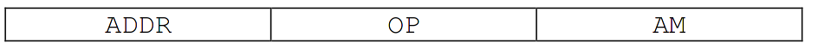
Bits 23-12 Bits 11 – 6 Bits 5-0
The basic unit of computation in our machine is the OP code. OPCODE’s are represented by uint32_t type integers and simulate 24 bit numbers. An OPCODE is compiresed of 3 parts, the Address (bits 23-12) which is a 3 HEX digit number usually representing a place in RAM, an Operator (bits 11 -6) which Represent indexes on the Figure 1.4. And is used to tell the B17 which operation to perform. There are 64 possible instructions although only 22 are presently in use. Attempting to Use an undefined operation will cause the Simulation to HALT and ERR. And The final part is the Addressing Mode (bits 5-0) discussed previously.

Figure 1.4 Operator Graph

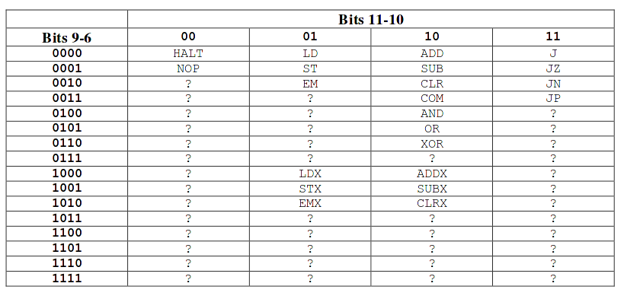
Halt States:
Inorder to simulate a real computer better Several HALT states have been introduced to help with debugging. If the program ever enters a state where it cannot proceed due to poor data or is given the HALT OPCODE the machine will print “Machine Halted - “ followed by one of the messages from Figure 1.5. These messages can give key information as to why your simulation is running about as well as Windows ME.
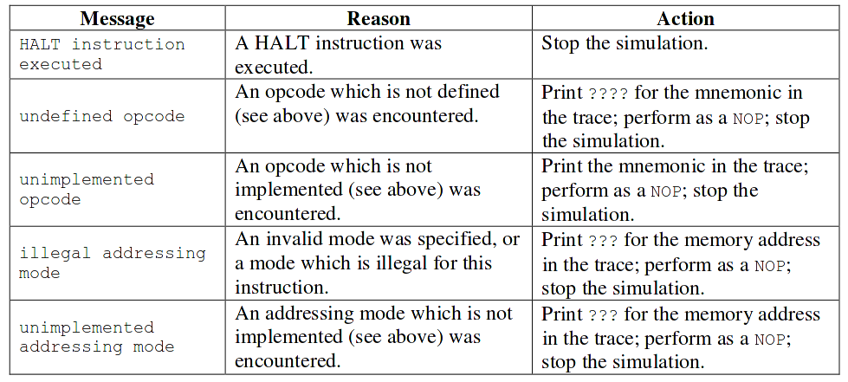
Figure 1.5 Halt Messages

Implimentation

b17.cpp:

Functions:
uint32_t countNumberOfLinesInFile(char* filename): This function counts and returns the number of lines in the file by opening steping through line by line , closing the file then exiting.
void decodeToInstruction(instruction &instruct): This function accesses the 32bit integer IR as one of the global variables and parces its pieces into instruct in the proper way. Only the lower 24 bits are used as that is the size of an OPCODE.
void runInstruction(instruction $instruct ): This function calls the function pointer array that holds the functions containing the operators. (see operators.c)
int32_t loadProgram(char* filename, uint32_t numLines): This function runs through a given file and while detecting error places the numbers into the RAM array
void startProgram(uint32_t addresssOfFirstInstruction ): This fucntion sets up the main loop places the first opcode into memory and begins the main loop.
void printTrace(instruction instruct, uint32_t address, uint32_t instruction, ostream &out): Part of the specifiation is that every cycle the program is to print a trace consisting of the values in each register along with the line of code being run, the value at that line, the effective address being used and the Mnmonic for the operation.
void printAddressMode( instruction instruct ): Helper function that properly prints out what addressing mode each operator is using.
void haltingOutput( ): Function that handles output incase of crash or halting.

Operators.cpp
void RunMEM( char MemAcc ): Since we are trying to simulate a real machine this function performs a memory access as thought we were really using the B17. For Loading the address to load from must be present on the ABUS, and for Storing the address must be on the ABUS and the Value to store must be on the DBUS. It’s operand represents what type of memory access to do and has only 2 possible values _WRITEMEM and _READMEM which are ’d in operators.cpp
void RunALU( char operand): This function performs similar porpose as RunMEM() except it simulates an ALU operation in all cases except operations using the index registers the operands are first the accumulator and second what is present on the DBUS. Return values are placed in the ALU register and can be fetched from there. Its operand and again like RunMEM s that determine what operation to use they are.. _NOP_ , _ADD_ , _SUB_ , _COM_ , _CLR_ , _AND_ , _OR_ , _XOR_, _ADDX_, _SUBX_,_CLRX_ and the meanings should be evident.
int32_t getEA( instruction &instruc, char allowed ): This function Fetches the would be EA(Effective Address) for the operand instruct from RAM. This function will set error flags in the PSR if it is unable use the access mode provided in allowed. The operand ‘allowed’ should be ORed values from the address mode s in operators.cpp they are identified by the format _AM_XXX and are _AM_DIR , _AM_IMM, _AM_IND, _AM_IDR, _AM_IDI , _AM_ALL, standing for DIRect , IMMediate , INDexed, InDiRect, InDirect Indexed and ALL respectively.
int32_t getVal( instruction &instruc, char allowed ): This function Fetches the value at the EA(Effective Address) for the operand instruct from RAM. This function will set error flags in the PSR if it is unable use the access mode provided in allowed. The operand ‘allowed’ should be ORed values from the address mode s in operators.cpp they are identified by the format _AM_XXX and are _AM_DIR , _AM_IMM, _AM_IND, _AM_IDR, _AM_IDI , _AM_ALL, standing for DIRect , IMMediate , INDexed, InDiRect, InDirect Indexed and ALL respectively.\

OPERATORS:
The Operators are implmented as stated in the Figure 1.6. The only important thing to note is that due to abigous specifiations the arithmetic operators on the index registers use the lower 12 bits of its operand.
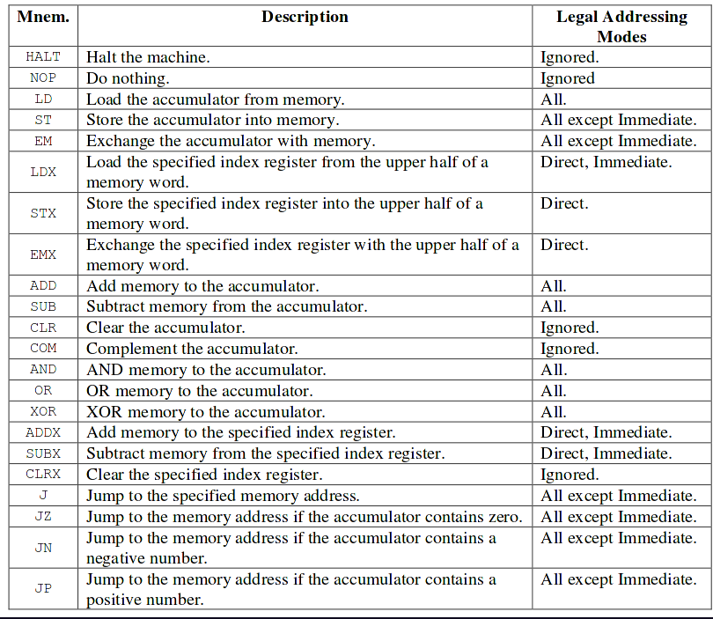

TESTING:
Several Test files are included with the B17 simulator. Each’s output has been hand tested and found to be correct. The Files and expeced output’s are as follows:
program1:
50 1 000000
c4 5 050404 200800 300800 102840 050c00
101 2 300 9
200 1 30
300 1 10
c4
output:
0c4: 050404 LD IMM AC[000050] X0[000] X1[000] X2[000] X3[000]
0c5: 200800 ADD 200 AC[000080] X0[000] X1[000] X2[000] X3[000]
0c6: 300800 ADD 300 AC[000090] X0[000] X1[000] X2[000] X3[000]
0c7: 102840 SUB 102 AC[000087] X0[000] X1[000] X2[000] X3[000]
0c8: 050c00 J 050 AC[000087] X0[000] X1[000] X2[000] X3[000]
050: 000000 HALT AC[000087] X0[000] X1[000] X2[000] X3[000]
Machine Halted - HALT instruction executed

program2:
50 1 000000
100 5 200400 201840 202800 005844 050c84
200 3 30 31 10
100
Output:
100: 200400 LD 200 AC[000030] X0[000] X1[000] X2[000] X3[000]
101: 201840 SUB 201 AC[ffffff] X0[000] X1[000] X2[000] X3[000]
102: 202800 ADD 202 AC[00000f] X0[000] X1[000] X2[000] X3[000]
103: 005844 SUB IMM AC[00000a] X0[000] X1[000] X2[000] X3[000]
104: 050c84 JN ??? AC[00000a] X0[000] X1[000] X2[000] X3[000]
Machine Halted - illegal addressing mode

program3:
50 1 000000
75 3 30 20 10
ff 7 075400 040804 077440 005884 076400 077800 0309c4
ff
Output:
0ff: 075400 LD 075 AC[000030] X0[000] X1[000] X2[000] X3[000]
100: 040804 ADD IMM AC[000070] X0[000] X1[000] X2[000] X3[000]
101: 077440 ST 077 AC[000070] X0[000] X1[000] X2[000] X3[000]
102: 005884 CLR IMM AC[000000] X0[000] X1[000] X2[000] X3[000]
103: 076400 LD 076 AC[000020] X0[000] X1[000] X2[000] X3[000]
104: 077800 ADD 077 AC[000090] X0[000] X1[000] X2[000] X3[000]
105: 0309c4 ???? IMM AC[000090] X0[000] X1[000] X2[000] X3[000]
Machine Halted - undefined opcode

program4:
50 1 000000
c4 5 015400 005804 016440 005884 0a1c40
a1 8 016602 900062 017a02 018682 018400 016a00 1118c1 0b7c80
b7 7 000884 005a41 010a41 000a80 007642 000a82 0e2c00
e2 6 007400 02a804 015984 013904 04b944 050cc0
15 5 10000 20 30 987000 0a1
c4
output:
0c4: 015400 LD 015 AC[010000] X0[000] X1[000] X2[000] X3[000]
0c5: 005804 ADD IMM AC[010005] X0[000] X1[000] X2[000] X3[000]
0c6: 016440 ST 016 AC[010005] X0[000] X1[000] X2[000] X3[000]
0c7: 005884 CLR IMM AC[000000] X0[000] X1[000] X2[000] X3[000]
0c8: 0a1c40 JZ 0a1 AC[000000] X0[000] X1[000] X2[000] X3[000]
0a1: 016602 LDX 016 AC[000000] X0[000] X1[000] X2[010] X3[000]
0a2: 900062 NOP AC[000000] X0[000] X1[000] X2[010] X3[000]
0a3: 017a02 ADDX 017 AC[000000] X0[000] X1[000] X2[040] X3[000]
0a4: 018682 EMX 018 AC[000000] X0[000] X1[000] X2[987] X3[000]
0a5: 018400 LD 018 AC[040000] X0[000] X1[000] X2[987] X3[000]
0a6: 016a00 ADDX 016 AC[040000] X0[005] X1[000] X2[987] X3[000]
0a7: 1118c1 COM 016 AC[fbffff] X0[005] X1[000] X2[987] X3[000]
0a8: 0b7c80 JN 0b7 AC[fbffff] X0[005] X1[000] X2[987] X3[000]
0b7: 000884 CLR IMM AC[000000] X0[005] X1[000] X2[987] X3[000]
0b8: 005a41 SUBX 005 AC[000000] X0[005] X1[000] X2[987] X3[000]
0b9: 010a41 SUBX 010 AC[000000] X0[005] X1[000] X2[987] X3[000]
0ba: 000a80 CLRX 010 AC[000000] X0[000] X1[000] X2[987] X3[000]
0bb: 007642 STX 007 AC[000000] X0[000] X1[000] X2[987] X3[000]
0bc: 000a82 CLRX 007 AC[000000] X0[000] X1[000] X2[000] X3[000]
0bd: 0e2c00 J 0e2 AC[000000] X0[000] X1[000] X2[000] X3[000]
0e2: 007400 LD 007 AC[987000] X0[000] X1[000] X2[000] X3[000]
0e3: 02a804 ADD IMM AC[98702a] X0[000] X1[000] X2[000] X3[000]
0e4: 015984 XOR IMM AC[98703f] X0[000] X1[000] X2[000] X3[000]
0e5: 013904 AND IMM AC[000013] X0[000] X1[000] X2[000] X3[000]
0e6: 04b944 OR IMM AC[00005b] X0[000] X1[000] X2[000] X3[000]
0e7: 050cc0 JP 050 AC[00005b] X0[000] X1[000] X2[000] X3[000]
050: 000000 HALT AC[00005b] X0[000] X1[000] X2[000] X3[000]
Machine Halted - HALT instruction executed

program5:
50 1 000000
c4 5 015400 005804 016440 005884 0a1c40
a1 8 016602 900062 017a02 018682 018400 016a00 1118c1 0b7c80
b7 8 000884 005a41 010a41 000a80 007642 000a82 007480 0e2c00
e2 6 007400 02a804 015984 013904 04b944 050cc0
5 1 298645
10 1 123456
15 4 10000 20 30 987000
c4
output:
0c4: 015400 LD 015 AC[010000] X0[000] X1[000] X2[000] X3[000]
0c5: 005804 ADD IMM AC[010005] X0[000] X1[000] X2[000] X3[000]
0c6: 016440 ST 016 AC[010005] X0[000] X1[000] X2[000] X3[000]
0c7: 005884 CLR IMM AC[000000] X0[000] X1[000] X2[000] X3[000]
0c8: 0a1c40 JZ 0a1 AC[000000] X0[000] X1[000] X2[000] X3[000]
0a1: 016602 LDX 016 AC[000000] X0[000] X1[000] X2[010] X3[000]
0a2: 900062 NOP AC[000000] X0[000] X1[000] X2[010] X3[000]
0a3: 017a02 ADDX 017 AC[000000] X0[000] X1[000] X2[040] X3[000]
0a4: 018682 EMX 018 AC[000000] X0[000] X1[000] X2[987] X3[000]
0a5: 018400 LD 018 AC[040000] X0[000] X1[000] X2[987] X3[000]
0a6: 016a00 ADDX 016 AC[040000] X0[005] X1[000] X2[987] X3[000]
0a7: 1118c1 COM 016 AC[fbffff] X0[005] X1[000] X2[987] X3[000]
0a8: 0b7c80 JN 0b7 AC[fbffff] X0[005] X1[000] X2[987] X3[000]
0b7: 000884 CLR IMM AC[000000] X0[005] X1[000] X2[987] X3[000]
0b8: 005a41 SUBX 005 AC[000000] X0[005] X1[9bb] X2[987] X3[000]
0b9: 010a41 SUBX 010 AC[000000] X0[005] X1[565] X2[987] X3[000]
0ba: 000a80 CLRX 010 AC[000000] X0[000] X1[565] X2[987] X3[000]
0bb: 007642 STX 007 AC[000000] X0[000] X1[565] X2[987] X3[000]
0bc: 000a82 CLRX 007 AC[000000] X0[000] X1[565] X2[000] X3[000]
0bd: 007480 EM 007 AC[987000] X0[000] X1[565] X2[000] X3[000]
0be: 0e2c00 J 0e2 AC[987000] X0[000] X1[565] X2[000] X3[000]
0e2: 007400 LD 007 AC[000000] X0[000] X1[565] X2[000] X3[000]
0e3: 02a804 ADD IMM AC[00002a] X0[000] X1[565] X2[000] X3[000]
0e4: 015984 XOR IMM AC[00003f] X0[000] X1[565] X2[000] X3[000]
0e5: 013904 AND IMM AC[000013] X0[000] X1[565] X2[000] X3[000]
0e6: 04b944 OR IMM AC[00005b] X0[000] X1[565] X2[000] X3[000]
0e7: 050cc0 JP 050 AC[00005b] X0[000] X1[565] X2[000] X3[000]
050: 000000 HALT AC[00005b] X0[000] X1[565] X2[000] X3[000]
Machine Halted - HALT instruction executed
program6:
700 2 0e7058 703e56
700

output:
700: 0e7058 NOP AC[000000] X0[000] X1[000] X2[000] X3[000]
701: 703e56 ???? 000 AC[000000] X0[000] X1[000] X2[000] X3[000]
Machine Halted - undefined opcode
programtest:
50 1 000000
c4 5 015400 005804 016440 005884 0a1c40
a1 8 016602 900062 017a02 018682 018400 016a00
b7 8 000884 005a41 010a41 000a80 007642 000a82 007480 0e2c00
e2 6 007400 02a804 015984 013904 04b944 050cc0
5 1 298645
10 1 123456
15 4 10000 20 30 987000
c4
output:
ERROR FOUND IN INPUT FILE: INDEX OVERFLOW
Exiting.

